Name- Ms.Vaishali Mishra

Institution Mail Id- vaishali.mishra@viit.ac.in

1 INTRODUCTION

Now a days automation systems are everywhere whether its home, office or any big industry, all are equipped with automation systems. Restaurants/Hotels are also adopting recent automation trends and are installing robots to deliver food and tablets for taking orders. Using these digital menu cards like tablets, customers can easily select the items. This information will be sent to the kitchen of the Restaurant and also displayed on the display device like TV screen or monitor.

1.1 Overview

In this project, a chatbot is developed using Watson assistant. This Chatbot provides following capabilities:

1) Allows user to book a table in a restaurant

2) Shows the menu card

3) Shows different offers available in restaurant.

4) Allows customer to place an multiple order

5) The bot is in the position to confirm the order.

1.2 Purpose

The purpose of a Chatbot is to give immediate responses to the user's Frequently Answered Questions (FAQs) and provide services efficiently.

2 LITERATURE SURVEY

2.1 Existing problem

Artificial intelligence is on its way to a faster human lifestyle in an efficient way. Virtual bots have become handy nowadays by supporting various domains for smooth lives. Chatbots are helping many sectors by providing services in the form of information agents by effectively accomplishing tasks.

2.2 Proposed solution

Develop an end to end mobile application capable of managing/placing orders, displaying recommendations, showing the menu, prompting the best deals or collecting the customer feedback using the IBM Watson Assistant. The customer and the order details are stored in the Cloudant DB. Alert is sent when the order is confirmed using the Cloud Messaging. Speech to Text and Text to Speech Services must be used to take the speech input and give out the speech output.

Features

Using chatbot we can manage users reservations and orders

We can give food recommendations and display the menu to the users

We can Promote best deals and offers on that day

We will store the customer’s details and orders in the database

Chat will send a notification to customers if the order is confirmed

The chatbot is also useful in Follow up on customer feedback

3 THEORITICAL ANALYSIS

3.1 Block diagram?

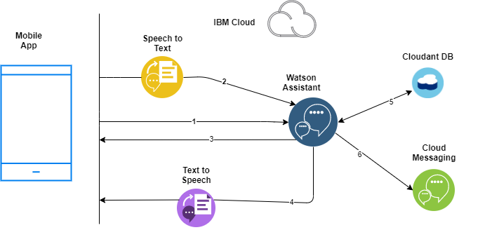

Figure 1. Block Diagram

3.2 Hardware / Software designing

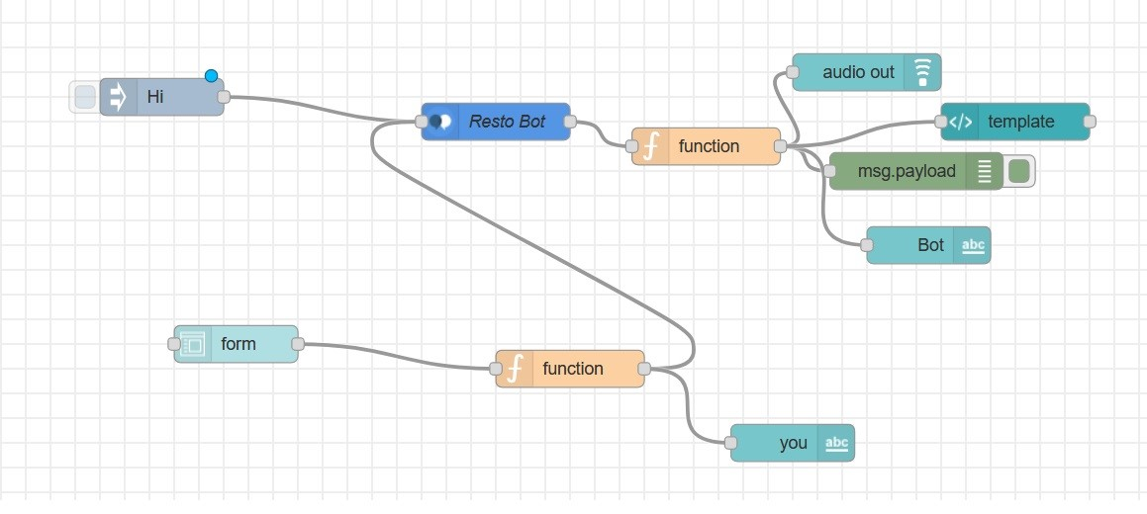

? Figure 2. Flow diagram of Node Red Application

4 FLOWCHART

Start

?

Welcome message

user Input

Enquiry

?

Book a table

Place order

Offers

Menu Card

Show offers

Booked a table

Show menu card

Order of item withquantity placed

Figure 3. Flowchart

5 RESULT

Screenshot:- Nodered UI

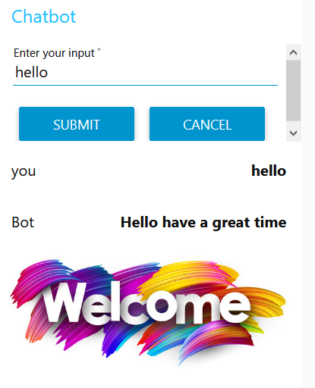 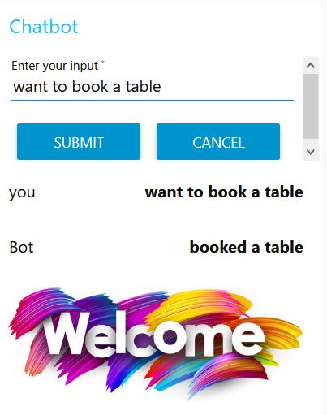 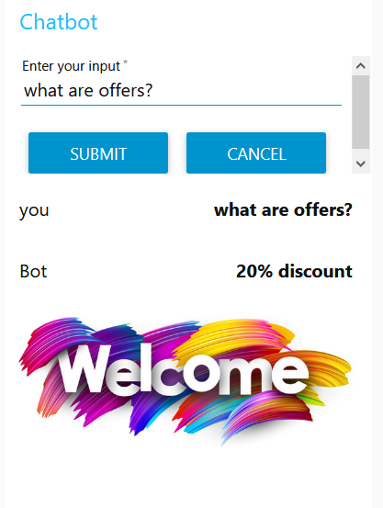

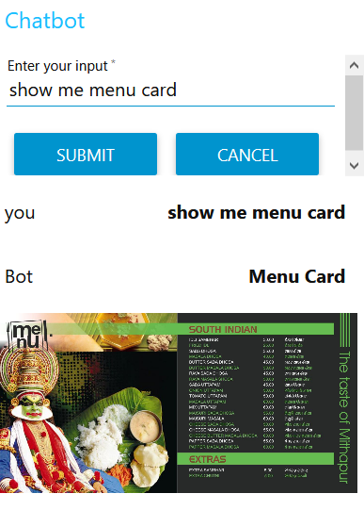 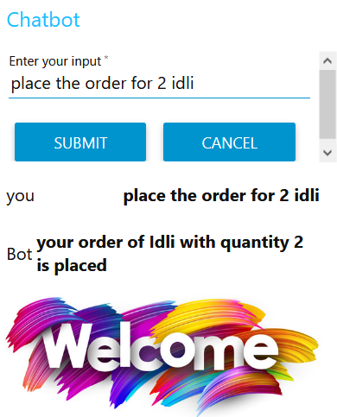

Screenshot:- Chatbot Preview Link Output

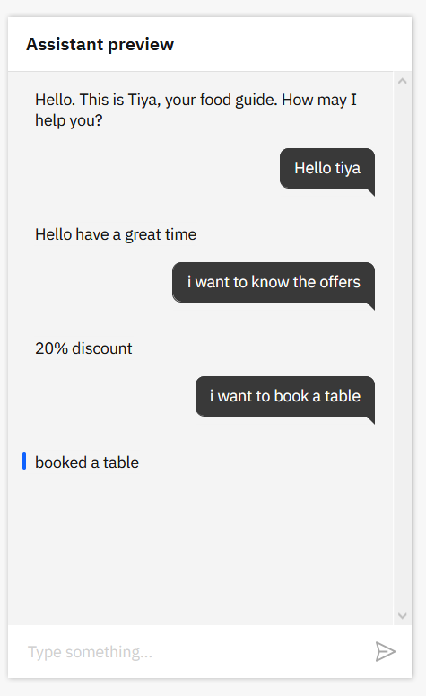 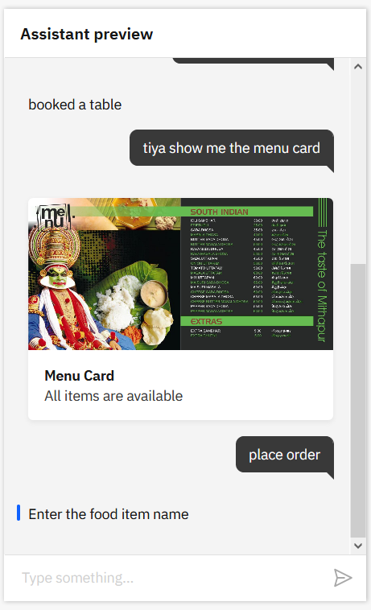 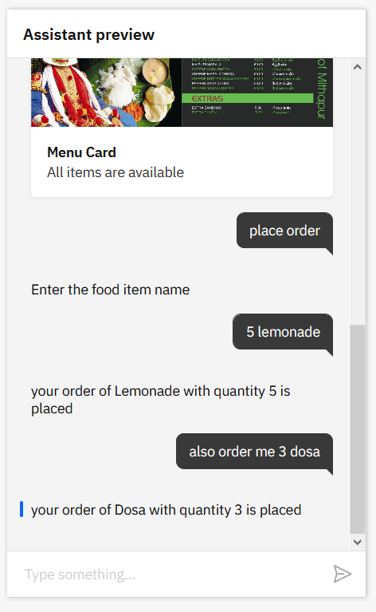

6 ADVANTAGES & DISADVANTAGES

Advantages:

1) Easy and quick to do the Restaurant Related Activity.

2) We can give order

3) We can check special /Offer related to menu.

4) We can access more information

Disadvantages:

1) Need to have knowledge about online transaction

2) Need to have credit card or similar type of payment entity

3) If website for the same is down then you will not be able to give order.

8 APPLICATIONSSmart Restaurant Bot 9 CONCLUSION

7 CONCLUSION:

This project is successfully functioning as per the objectives defined. This project helps to solve the problem faced by the restaurant in the attempt to organize the FAQ's and have more efficient outcome. It can also be used to reduce the lateness and the error caused on ordering foods by the customers through waiters. By using this system, the complaints about the services are eliminated

8 FUTURE SCOPE

Further enhancements can also be there through which this restaurant bot becomes more automated where billing and payment can be added.

9 BIBILOGRAPHYAPPENDIX

A. Source code

Chat Bot JSON File (Watson Assistant)

{

"intents": [

{

"intent": "Enquiry",

"examples": [

{

"text": "I want to reserve a table"

},

{

"text": "what are offers?"

},

{

"text": "what are the special for today"

},

{

"text": "What is the menu?"

},

{

"text": "Will I get any discounts"

}

],

"description": ""

},

{

"intent": "Greetings",

"examples": [

{

"text": "Good Afternoon"

},

{

"text": "Good Evening"

},

{

"text": "Good night"

},

{

"text": "Hello"

},

{

"text": "Hi"

}

],

"description": ""

},

{

"intent": "order",

"examples": [

{

"text": "i will like to order"

},

{

"text": "place order"

}

],

"description": ""

}

],

"entities": [

{

"entity": "Enquiry",

"values": [

{

"type": "synonyms",

"value": "menu",

"synonyms": [

"dishes",

"special"

]

},

{

"type": "synonyms",

"value": "offers",

"synonyms": [

"discounts"

]

},

{

"type": "synonyms",

"value": "reserve",

"synonyms": [

"book",

"reserve"

]

}

],

"fuzzy_match": true

},

{

"entity": "Food-items",

"values": [

{

"type": "synonyms",

"value": "coffee",

"synonyms": [

"hot coffee"

]

},

{

"type": "synonyms",

"value": "Cold Coffee",

"synonyms": []

},

{

"type": "synonyms",

"value": "Dosa",

"synonyms": []

},

{

"type": "synonyms",

"value": "Idli",

"synonyms": []

},

{

"type": "synonyms",

"value": "Lemonade",

"synonyms": []

},

{

"type": "synonyms",

"value": "Pani Puri",

"synonyms": []

}

],

"fuzzy_match": true

},

{

"entity": "Greetings",

"values": [

{

"type": "synonyms",

"value": "good Evening",

"synonyms": [

"gd eve",

"pleasant evening"

]

},

{

"type": "synonyms",

"value": "Good Morning",

"synonyms": [

"GD Morn",

"GM",

"morning"

]

}

],

"fuzzy_match": true

},

{

"entity": "sys-number",

"values": [],

"fuzzy_match": true

}

],

"metadata": {

"api_version": {

"major_version": "v2",

"minor_version": "2018-11-08"

},

"from-sample": true

},

"dialog_nodes": [

{

"type": "standard",

"title": "Anything else",

"output": {

"generic": [

{

"values": [

{

"text": "I didn't understand. You can try rephrasing."

},

{

"text": "Can you reword your statement? I'm not understanding."

},

{

"text": "I didn't get your meaning."

}

],

"response_type": "text",

"selection_policy": "sequential"

}

]

},

"conditions": "anything_else",

"dialog_node": "Anything else",

"previous_sibling": "node_7_1602792447149",

"disambiguation_opt_out": true

},

{

"type": "event_handler",

"output": {

"text": {

"values": [

"Enter the food item name"

],

"selection_policy": "sequential"

}

},

"parent": "slot_2_1602792600761",

"event_name": "focus",

"dialog_node": "handler_3_1602792600791",

"previous_sibling": "handler_9_1602792600791"

},

{

"type": "event_handler",

"output": {

"text": {

"values": [

"Enter the quantity"

],

"selection_policy": "sequential"

}

},

"parent": "slot_6_1602792779832",

"event_name": "focus",

"dialog_node": "handler_5_1602792779837",

"previous_sibling": "handler_7_1602792779837"

},

{

"type": "event_handler",

"output": {},

"parent": "slot_6_1602792779832",

"context": {

"number": "@sys-number"

},

"conditions": "@sys-number",

"event_name": "input",

"dialog_node": "handler_7_1602792779837"

},

{

"type": "event_handler",

"output": {},

"parent": "slot_2_1602792600761",

"context": {

"Food_items": "@Food-items"

},

"conditions": "@Food-items",

"event_name": "input",

"dialog_node": "handler_9_1602792600791"

},

{

"type": "standard",

"title": "Greetings Node",

"metadata": {

"_customization": {

"mcr": true

}

},

"conditions": "#Greetings || @Greetings",

"dialog_node": "node_3_1602788013840",

"previous_sibling": "Welcome"

},

{

"type": "frame",

"title": "order food",

"output": {

"generic": [

{

"values": [

{

"text": "your order of $Food_items with quantity $number is placed"

}

],

"response_type": "text",

"selection_policy": "sequential"

}

]

},

"next_step": {

"behavior": "skip_user_input"

},

"conditions": "#order",

"dialog_node": "node_7_1602792447149",

"previous_sibling": "node_9_1602789833608"

},

{

"type": "standard",

"title": "Enquiry",

"metadata": {

"_customization": {

"mcr": true

}

},

"conditions": "#Enquiry",

"dialog_node": "node_9_1602789833608",

"previous_sibling": "node_3_1602788013840"

},

{

"type": "standard",

"title": "Deleting the context variable",

"output": {

"deleted": "<?context.remove('food_items')?><?context.remove('number')?>",

"generic": [

{

"values": [],

"response_type": "text",

"selection_policy": "sequential"

}

]

},

"parent": "node_7_1602792447149",

"conditions": "true",

"dialog_node": "node_9_1602793097890"

},

{

"type": "response_condition",

"output": {

"generic": [

{

"values": [

{

"text": "good morning excellent day"

}

],

"response_type": "text",

"selection_policy": "sequential"

}

]

},

"parent": "node_3_1602788013840",

"conditions": "@Greetings:(Good Morning)",

"dialog_node": "response_10_1602788948343"

},

{

"type": "response_condition",

"output": {

"generic": [

{

"values": [

{

"text": "good evening"

}

],

"response_type": "text",

"selection_policy": "sequential"

}

]

},

"parent": "node_3_1602788013840",

"conditions": "@Greetings:(good Evening)",

"dialog_node": "response_1_1602789084948",

"previous_sibling": "response_10_1602788948343"

},

{

"type": "response_condition",

"output": {

"generic": [

{

"values": [

{

"text": "Hello have a great time"

}

],

"response_type": "text",

"selection_policy": "sequential"

}

]

},

"parent": "node_3_1602788013840",

"conditions": "anything_else",

"dialog_node": "response_1_1602791785762",

"previous_sibling": "response_1_1602789084948"

},

{

"type": "response_condition",

"output": {

"generic": [

{

"values": [

{

"text": "20% discount"

}

],

"response_type": "text",

"selection_policy": "sequential"

}

]

},

"parent": "node_9_1602789833608",

"conditions": "@Enquiry:offers",

"dialog_node": "response_2_1602791689977",

"previous_sibling": "response_5_1602789939053"

},

{

"type": "response_condition",

"output": {

"generic": [

{

"values": [

{

"text": "gd even mpk"

}

],

"response_type": "text",

"selection_policy": "sequential"

}

]

},

"parent": "node_3_1602788013840",

"conditions": "@Greetings:(good Evening)",

"dialog_node": "response_4_1602869738980",

"previous_sibling": "response_1_1602791785762"

},

{

"type": "response_condition",

"output": {

"generic": [

{

"title": "Menu Card",

"source": "https://www.aabhishek.com/wp-content/uploads/2016/07/restaurants-2.jpg",

"description": "All items are available ",

"response_type": "image"

}

]

},

"parent": "node_9_1602789833608",

"conditions": "@Enquiry:menu",

"dialog_node": "response_5_1602789939053"

},

{

"type": "response_condition",

"output": {

"generic": [

{

"values": [

{

"text": "booked a table"

}

],

"response_type": "text",

"selection_policy": "sequential"

}

]

},

"parent": "node_9_1602789833608",

"conditions": "@Enquiry:reserve",

"dialog_node": "response_5_1602876151136",

"previous_sibling": "response_2_1602791689977"

},

{

"type": "slot",

"parent": "node_7_1602792447149",

"variable": "$Food_items",

"dialog_node": "slot_2_1602792600761",

"previous_sibling": "node_9_1602793097890"

},

{

"type": "slot",

"parent": "node_7_1602792447149",

"variable": "$number",

"dialog_node": "slot_6_1602792779832",

"previous_sibling": "slot_2_1602792600761"

},

{

"type": "standard",

"title": "Welcome",

"output": {

"generic": [

{

"values": [

{

"text": "Hello. This is Tiya, your food guide. How may I help you?"

}

],

"response_type": "text",

"selection_policy": "sequential"

}

]

},

"conditions": "welcome",

"dialog_node": "Welcome"

}

],

"counterexamples": [],

"system_settings": {

"off_topic": {

"enabled": true

},

"disambiguation": {

"prompt": "Did you mean:",

"enabled": true,

"randomize": true,

"max_suggestions": 5,

"suggestion_text_policy": "title",

"none_of_the_above_prompt": "None of the above"

},

"system_entities": {

"enabled": true

},

"human_agent_assist": {

"prompt": "Did you mean:"

},

"spelling_auto_correct": true

},

"learning_opt_out": false,

"name": "Restaurant Bot",

"language": "en",

"description": ""

}

NodeRed Json File

[{"id":"41bb97b6.7ce3a","type":"tab","label":"Flow 3","disabled":false,"info":""},{"id":"d8bdbcc9.e014d","type":"watson-conversation-v1","z":"41bb97b6.7ce3a","name":"Resto Bot","workspaceid":"7b92b41d-e209-441d-9ee3-9dc8d19ef278","multiuser":false,"context":true,"empty-payload":false,"service-endpoint":"https://api.us-south.assistant.watson.cloud.ibm.com/instances/b42dc72e-f9f3-468a-8003-b56012d0bd41","timeout":"","optout-learning":false,"x":440,"y":120,"wires":[["86a4657d.67f13"]]},{"id":"6a2f9a00.13122","type":"inject","z":"41bb97b6.7ce3a","name":"","props":[{"p":"payload"},{"p":"topic","vt":"str"}],"repeat":"","crontab":"","once":false,"onceDelay":0.1,"topic":"","payload":"Hi ","payloadType":"str","x":170,"y":100,"wires":[["d8bdbcc9.e014d"]]},{"id":"ee82f552.1c74f","type":"debug","z":"41bb97b6.7ce3a","name":"","active":true,"tosidebar":true,"console":false,"tostatus":false,"complete":"payload","targetType":"msg","x":780,"y":160,"wires":[]},{"id":"86a4657d.67f13","type":"function","z":"41bb97b6.7ce3a","name":"","func":"if(msg.payload.output.generic[0].response_type==\"image\"){\n msg.url = msg.payload.output.generic[0].source\n msg.payload = msg.payload.output.generic[0].title\n}\nelse{\n msg.url=\"https://t3.ftcdn.net/jpg/02/20/14/38/240_F_220143804_fc4xRygvJ8bn8JPQumtHJieDN4ORNyjs.jpg\"\n msg.payload = msg.payload.output.text[0];\n}\nreturn msg;","outputs":1,"noerr":0,"initialize":"","finalize":"","x":610,"y":140,"wires":[["ee82f552.1c74f","86b804c3.955d3","77927e4.ad0f08","205db8d0.9098d8"]]},{"id":"a1a8084b.d597e8","type":"function","z":"41bb97b6.7ce3a","name":"","func":"msg.payload=msg.payload.text;\nreturn msg;","outputs":1,"noerr":0,"x":500,"y":320,"wires":[["d8bdbcc9.e014d","2e787ca0.7ac384"]]},{"id":"e6980d14.d52558","type":"ui_form","z":"41bb97b6.7ce3a","name":"","label":"","group":"530fb84a.416f28","order":2,"width":0,"height":0,"options":[{"label":"Enter your input","value":"text","type":"text","required":true,"rows":null}],"formValue":{"text":""},"payload":"","submit":"submit","cancel":"cancel","topic":"","x":230,"y":300,"wires":[["a1a8084b.d597e8"]]},{"id":"2e787ca0.7ac384","type":"ui_text","z":"41bb97b6.7ce3a","group":"530fb84a.416f28","order":3,"width":0,"height":0,"name":"","label":"you","format":"{{msg.payload}}","layout":"row-spread","x":680,"y":380,"wires":[]},{"id":"86b804c3.955d3","type":"ui_text","z":"41bb97b6.7ce3a","group":"530fb84a.416f28","order":4,"width":0,"height":0,"name":"","label":"Bot","format":"{{msg.payload}}","layout":"row-spread","x":790,"y":220,"wires":[]},{"id":"77927e4.ad0f08","type":"ui_audio","z":"41bb97b6.7ce3a","name":"","group":"530fb84a.416f28","voice":"en-US","always":"","x":740,"y":80,"wires":[]},{"id":"205db8d0.9098d8","type":"ui_template","z":"41bb97b6.7ce3a","group":"530fb84a.416f28","name":"","order":6,"width":"6","height":"11","format":"<img ng-src={{msg.url}} alt=\"Image\">","storeOutMessages":true,"fwdInMessages":true,"resendOnRefresh":true,"templateScope":"local","x":860,"y":120,"wires":[[]]},{"id":"530fb84a.416f28","type":"ui_group","z":"41bb97b6.7ce3a","name":"Chatbot","tab":"1df1b253.52b42e","order":1,"disp":true,"width":"6","collapse":false},{"id":"1df1b253.52b42e","type":"ui_tab","z":"41bb97b6.7ce3a","name":"Resto Bot","icon":"dashboard","disabled":false,"hidden":false}]